Communication about Student Learning

Double Churches Middle is committed to frequent two-way communication with families about children’s learning. Some of the ways you can expect us to reach you are:

- Student Agenda Book
- Updates on the school’s website and Instagram page
- Grade level meetings on understanding student progress
- Parent-teacher conferences
- Current grades on the Parent Portal
- Canvas

Double Churches Middle School
Mr. Eddie Lindsey, Principal
Leslie Hemmings, Assistant Principal
7611 Whitesville Road
Columbus, GA. 31904
Office: 706-748-2678

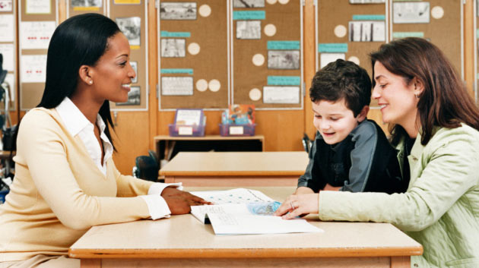

What is a School-Parent Compact?

A School-Compact for Achievement is an agreement that parents, students and teachers develop together. It explains how parents and teachers will work together to make sure all our students reach grade-level standards.

Effective School-Parent Compacts:

- Link to goals of the School Improvement Plan
- Focus on student learning skills
- Describe how teachers will help students develop those skills using high-quality instruction
- Share strategies parents can use at home
- Explain how teachers and parents will communicate about student progress
- Describe opportunities for parents to volunteer, observe and participate in the classroom

How is the School-Parent Compact Developed?

The parents, students, and staff at Double Churches Middle School developed this School-Parent Compact for Achievement. Teachers suggested home learning strategies, parents add ideas to make them more specific, and students told us what would help them learn. Meetings are held each year to review the Compact and make changes based on student needs.

.

Parents are welcome to contribute and provide input at any time.
If you would like to volunteer, and /or observe in the classroom please contact the school at 706-748-2678
2019-2020
Revised 8/14/19

R
r
Re
Double Churches Middle School

District Goals
The Muscogee County School District will implement evidence-based Tier 1 instruction, a Multi-Tiered System of Support (MTSS), leadership development, and a culture of kindness.
School Improvement Goals
(6th- 8th grades)
Instructional Goal: By May 2020, 100% of teachers will be trained on the use of formative assessment data to differentiate instruction through the use of small groups with 85% of successful teacher implementation as measured by informal and formal walkthroughs.
Climate Goal: By May 2020, 100% of teachers and staff will make positive student-parent contacts by having goal-setting meetings with ILT students every nine weeks.

Our Students:
Students are encouraged to participate in the educational process. A successful student takes ownership of his/her learning and sets high educational goals.
- Set goals for myself to succeed in school
- Display positive behaviors in school
- Work on Achieve 3000 at home
- Work on my core skills at home, using the materials my teacher sends home

Our Parents:
Parents are expected to participate in the education of their children. Without the cooperation and partnership between parents and school staff, we cannot effectively help a student reach his or her full potential. The major role of parents is to continually show the child that they are interested and supportive of how their child is doing in school.
- Monitor my child’s use of Achieve 3000 at home
- Practice strategies and activities the teacher sends home to improve my child’s academic and behavior skills
- Communicate with my child’s teacher regarding any questions or concerns about your child’s individual goals for learning

Our Teachers:
Teachers are expected to work with students and their families to support students’ success in reading and math. Some of our key connections with families will be:
- Reward students according to PBIS protocol
- Collect data to ensure differentiation
- Establish open lines of communication with parents concerning their child’s school performance and behavior
- Coordinate activities for all subjects and share strategies with families on how to help students at home

