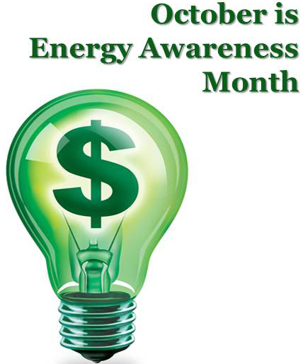

**ENERGY AWARENESS ESSAY CONTEST**

**The federal government faces even more challenging goals to reduce energy consumption as they plan for Federal Sustainability in the Next Decade. Agencies are committed to stepping up and adopting more sustainable operations to cut greenhouse gas emissions and reduce taxpayer energy costs. The Capital Solar Challenge, and the Better Buildings Data Center Challenge, as well as through day-to-day operations and projects, federal agencies are working hard year-round to meet stringent energy management goals, and they continue to lead our nation to a secure, clean, and prosperous energy future.  The Federal Energy Management Program (FEMP) provides resources and tools that help agencies implement renewable energy projects and technologies to meet federal laws and requirements.**

**In your own words describe two types of alternate sources of energy. What are the advantages and disadvantages? Would these forms of energy be a potential solution to deal with an energy crisis?**

**CRITERIA**

* **Length must be 750-1000 words**
* **Typed paper in Times New Roman 12 font**
* **Cover page….Title of Paper, Name, Date**
* **Reference page and Citation** 
  + **FIRST PLACE-$100.00**
  + **SECOND PLACE-$75.00**
  + **THIRD PLACE-$50.00**
* **Due: Friday, November 9, 2018**

**SPONSORED BY THE**

**GEORGE WASHINGTON CARVER HIGH SCHOOL PARTNERS IN EDUCATION**