Communication about Student Learning

- Class Dojo
- Connect-Ed messages
- Updates on the school’s website
- Parent-teacher conferences
- Parent Portal

Principal
Dr. M. Cenobia Moore

Assistant Principal
Mrs. Katherine G. Lopez

2951 Martin Luther King BLVD.
Columbus, Georgia 31906
706-748-2479
www.muscogee.k12.ga.us/brewer/

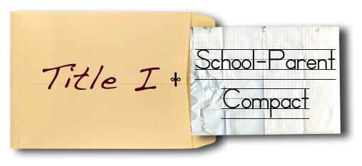

What is a School-Parent Compact?

A School-Parent Compact is an agreement that parents, students, and teachers develop together. It explains how parents, students and teachers will work toward becoming lifelong learners. Meetings are held each year to review the compact and make changes based on student needs. Parents are welcome to contribute comments at any time. For all students who reside in residential facilities served by the Muscogee County school District, parental involvement correspondence and activities will be mailed to each facility where students reside.

Effective School-Parent Compacts:
- Link to goals of the School Improvement Plan.
- Focus on student learning skills.
- Describe how teachers will help students develop those skills using high-quality instruction.
- Share strategies parents can use at home.
- Explain how teachers and parents will communicate about student progress.

2013-2014

School-Parent Compact 2015-2016
Revised 12/10/15

BREWER ELEMENTARY
School-Parent Compact
2017-2018
Revised 9-25-17

ALLEN

District Goals
The Muscogee County School District will create an environment that focuses in Tier 1 instruction while targeting individual student needs, leadership development, and customer service.

School’s SMART Goals

- By May 2018, 90% of teachers will be proficient in all four PBIS Classroom modules as evidenced by monthly aggregate walkthrough data.
- By May 2018, 90% of all teachers will incorporate the Writers Workshop model across the curriculum and other collaborative processes to increase student learning as measured through focus walks and student data.

Our Students:
Students are encouraged to participate in the educational process. A successful student takes ownership of his/her learning and sets high educational goals..

As a school, we will…..
- Provide the needed tools to reach school goals and personal goals successfully.
- Help parents stay connected through multiple ways of communication. Parent-teacher conferences, Parent Portal, and the school’s website.
- Teachers will effectively develop and implement classroom rules and routines matrix, an acknowledgement system, and a consequence system for academic engagement.
- Engage students in active learning and monitor student progress to ensure student success.

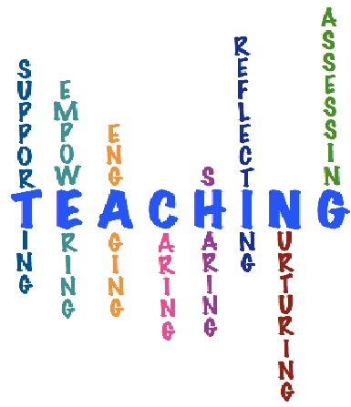

As parents, we will….
- Work with teachers to help my child reach his/her school and personal goals.
- Communicate with my child’s teacher regarding any questions or concerns about my child’s goals, academic performance, and behavior.
- Know my child’s Lexile score and ensure my child reads 20 minutes each night for literacy practice.
- Work with teachers to effectively improve the writing process across all
content areas.

As students, we will…..
- Work with my teachers and parents to help me become successful.
- Work hard on school and personal goals.
- Work on positive behavior.
- Know my Lexile score and read for 20 minutes each night for reading practice.

[Grab your reader’s attention with a great quote from the document or use this space to emphasize a key point. To place this text box anywhere on the page, just drag it.]
[Grab your reader’s attention with a great quote from the document or use this space to emphasize a key point. To place this text box anywhere on the page, just drag it.]
[Cite your source here.]

