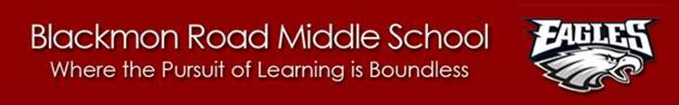

Kiwanis Club of Columbus

T. Hiram Stanley Awards Interest Letter and Information

Dear 8th Grade Student and Parent,

We are pleased to inform you that the Kiwanis Club of Columbus is planning to provide the T. Hiram Stanley Awards to promising 8th graders from schools in Muscogee County School District. This award recognizes our school’s most outstanding student. Only one student is selected from Blackmon Road to represent the school in the district competition. The selected student must participate in the required interview on Tuesday, April 24, 2018, and the district awards program on Tuesday, May 15, 2018 (more details to follow to selected student). To be considered, completed applications, including all materials below, are due no later than Friday, March 23 at 3:30 PM to the BRMS counseling office. School interviews will be held for those candidates meeting all criteria on Tuesday, April 3, throughout the day. The winner will be announced by Thursday, April 5. The final application will be submitted to the Kiwanis Club on Friday, April 6.

Interested applicants should have the following qualifications/materials:

* Superior Cumulative Grade Averages (A- Average and above) *
* Superior Report Card Grades (A- Average and above) *
* Superior Test Scores (GA Milestones and/or End-of-Grade Assessments or equivalent)
* Superior Attendance Record
* No major behavior infractions (ISS or OSS)
* Distinguished Scholastic honors, awards, recognitions, participation in extracurricular school activities, etc. in grades 6-8th
* Principal’s Recommendation
* 3 Academic Teacher Recommendations
* Student Resume—Please show student’s school(s) attended, involvement in school extracurricular and athletic activities, and participation in and recognition received from community service and civic or religious organizations.
* Student’s Statement—A handwritten statement, not to exceed 2 pages, showing the student’s attitudes, aspirations, and goal in education and life.
* Interview with BRMS Administration Panel on selected date.

*The school has records of the student’s grade averages, report cards, and test scores. We will provide this information.

The BRMS Administrative Team will meet to review all completed applications. Only the students meeting **all** qualifications listed above and submitting the information on time will be interviewed by the interview team. Only one person will be selected to represent Blackmon Road Middle School based on their application, resume, qualifications, and interview skills.

Respectfully,

The BRMS Administration Team