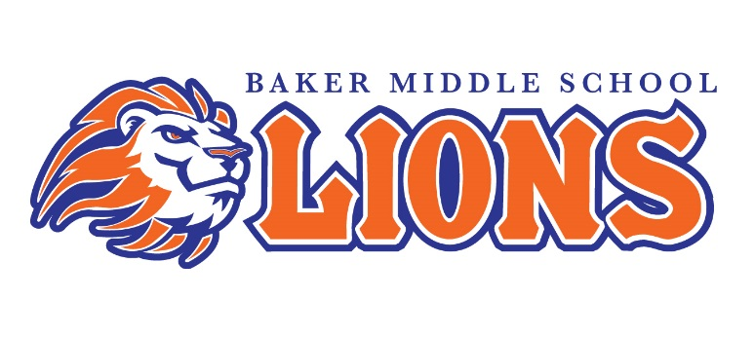

Student Uniform Guidelines

With MCSD Board approval, a school uniform policy has been adopted. ALL students are required to wear uniforms Monday through Friday with the following exceptions:
- Jeans on Fridays only if worn with official school t-shirt | - Picture Days
- Other Announced Special Events | - The last week of school

Special Notes:
- All shoes must be rubber-soled with enclosed toes and heels; tennis shoes preferred
- Not permitted: Oversized clothing, sagging, camouflage, leggings/jeggings, hoodies, cropped tops, or high heels
- Not permitted outside of lockers: Jackets, coats, book bags, string bags, or oversized purses

Please read MCSD and Baker Middle School student handbooks for detailed dress code information.

6th graders will begin their PRIDE journey with the following dress code:
Shirts: Collared navy polo-styled uniform shirt or dress shirt (long or short sleeves) with no emblems. Shirts must be tucked in.

7th graders will set the tone for excellence with the following dress code:
Shirts: Collared light blue polo-styled uniform shirt or dress shirt (long or short sleeves) with no emblems. Shirts must be tucked in.

8th graders will exemplify success with the following dress code:
Shirts: Collared white polo-styled uniform shirt or dress shirt (long or short sleeves) with no emblems. Shirts must be tucked in.

All Students:
Bottoms: Khaki uniform pants, skirts, shorts, etc. A belt must be worn if belt loops are present. Bottoms cannot be oversized and must be worn at natural waist. Shorts, skirts, etc. cannot be more than 2 inches above the knees.
*School ID on school lanyard must be worn around the neck daily*

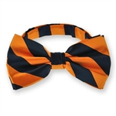
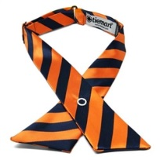
Optional for any student: Navy cardigan, blazer, sweater vest with no emblems, navy and orange ties or bow tie
www.tiemart.com

